St. Francis Xavier’s Church, Liverpool
17th May 2026
www.sfxchurch.co.uk

St Francis Xavier’s Church. Salisbury Street. Liverpool. L3 8DR
Phone: 0151 298 1911 Email: sfxchurch@rcaol.org.uk
Parish Priest: Fr. Chris McCoy.
7th SUNDAY OF EASTER. Year A.
Mass Readings. Page 653

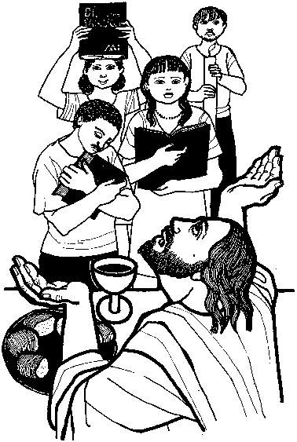

Today gospel: John 17:1-11
Jesus raised his eyes to heaven and said,
‘Father the hour has come glorify your son…
And let him give eternal life to all those
You have entrusted to him.’

FIRST COMMUNIONS. Some 13 children from Faith Primary have registered for First Communion this year. (There are several other children from other schools.) The First Communion mass will be on Saturday 6th June at 12 noon.

TEA, COFFEE & CAKE. Will be served after mass today. (Sunday)

TUESDAY SOCIAL GROUP The group meet this week on Tuesday at 1.30pm in the parish meeting room. All welcome.

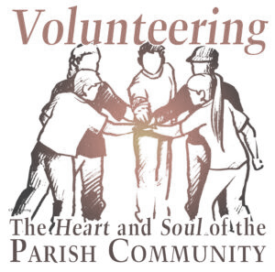
A VARIETY OF GIFTS Here at SFX we have a whole variety of people who, behind the scenes. help the parish run smoothly. For instance, over the past couple of months a tremendous amount of work has been done on preparing the DBS forms for all our parish volunteers. The process has been frustrating at times but thankfully all the applications are now in process. We owe a big thank you to all concerned. This is just one example of the quiet generous work that goes on behind the scenes. Readers, eucharistic minsters, sacristan, bookkeepers, collectors, counters, altar servers the list is endless. Thank you one and all.

ALL WELCOME! 'MANY VOICES-ONE FAITH.' 24th May 2026, 3-5pm
As the Feast of Pentecost approaches and we remember the moment when the early Christians were flooded with the Holy Spirit and carried the Gospel out into the crowds, Christians across the Archdiocese region are preparing to come together in celebration at this year’s Two Cathedrals Pentecost Walk. Inspired by Pope John Paul II’s journey down Hope Street in 1982, the Two Cathedrals Pentecost Walk is… denominations to come together in celebration.
The Two Cathedrals Walk will take place next Sunday 24th May at 3pm. All are warmly welcome to join us in gathering at the Metropolitan Cathedral of Christ the King for a walk down Hope Street to Liverpool Cathedral in a time for a short service celebration there.
For more information,
visit: https://www.ctmr.org.uk/Groups/341586/Pentecost.aspx

MARRIAGE ENCOUNTER EXPERIENCE IN LIVERPOOL The Marriage Encounter Experience offers the opportunity to refresh, enrich, deepen and bring love, joy and sparkle back into marital relationships. The experience is priest-led with laity couple presenters, and offers precious quality time to support lifelong marriage, personal growth and spiritual growth in a Catholic faith context. The experience is also open to couples in long term relationships, who are often drawn into marriage as a consequence through the sessions on the power of the sacrament and covenant love.

In partnership with the Archdiocese, a Marriage Encounter experience will be taking place at the St Margaret Clitherow Centre on Saturday 27th and 28th June 2026. The full details of how to register and take part can be found on the website https://wwme.org.uk.

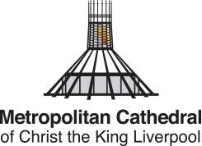
CATHDRAL CHOIR Applications are open for children currently in Years 2–5 to audition for the Cathedral Choir at Liverpool Metropolitan Cathedral. Choristers receive exceptional musical training, sing at regular services and special events, and become part of a welcoming and supportive choir community. If you know a child who loves to sing, we would love to hear from you. The recruitment flyer and video include more information about choir life and how to apply. Watch the video at: archdioceseofliverpool.org/choristervid

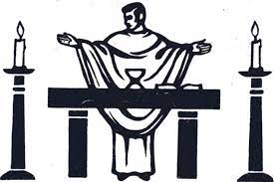
SERVICES: 17th May Onwards.
Tuesday | Mass | 12 noon | Terry Harvey
Thursday | Requiem Mass | 11.30am | Peter Williams RIP
Saturday | Mass | 12 noon | John More
Sunday | Mass | 10.15am | Parishioners

PLEASE REMEMBER IN YOUR PRAYERS THE FOLLOWING: Peter William RIP. David Neary RIP. Harry Barlow, Frank Sedgewick, Dorren Alderson RIP, Margaret William RIP, Anthony Hughes, Catherine Edwards Kevin Grimes, Kieran Neary, Marie Foy, Joan Moore, William Devine, Terry Turner, Dorothy Baker.

COLLECTION LAST WEEK £315.19. Thank you for supporting our parish.
Several people have asked if they could make regular donations by Standing Order. There are forms available in the sacristy if you would like to do this.

Click to donate to the parish.

£5 £10 £20

