St. Francis Xavier’s Church, Liverpool
29th June 2026
www.sfxchurch.co.uk

St Francis Xavier’s Church. Salisbury Street. Liverpool. L3 8DR
Phone: 0151 298 1911 Email: sfxchurch@rcaol.org.uk
Parish Priest: Fr. Chris McCoy
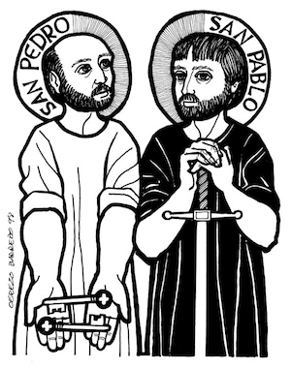
29th June
FEAST OF SAINT PETER & PAUL

Mass Readings. Page 714

FIRST COMMUNION TODAY Evelyn Bailey will be making her First Communion today at the 10.15am mass. Congratulations to Evelyn.

TUESDAY SOCIAL GROUP Meet this week. 1.30pm in the parish meeting room. All welcome.

NEXT SUNDAY 5th JULY.
3.30pm EXPOSITION ON THE BLESSED SACRAMENT
4.30pm. BENEDICTION

Afternoon Tea will be served in the garden at 4.45 after the Benediction. Come along for all or part of the afternoon.

SUNDAY 12TH JULY. 11am-1pm PARISH BBQ & TOMBOLA. After the 10.15 mass, in the garden we are having a parish BBQ. All welcome.

L8 INTERFAITH WALK– Thursday 2nd July St Philip Neri Church, together with other places of worship in the area, are organising a community walk to learn about faiths and explore our places of worship in L8. Starting with a tour of St Philip Neri at 5pm, the walk will take you to the Greek Orthodox Church of St Nicholas, Princes Road Synagogue, Al Rahma Mosque, before finishing with a meal at the World Faith Café at 8:15pm.

SAFEGUARDING IN THE ARCHDIOCESE AND IN OUR PARISH Every human being has a value and dignity which we as Catholics acknowledge as coming directly from God’s creation of male and female in his own image and likeness. We believe therefore that all people should be valued, supported, and protected from harm.
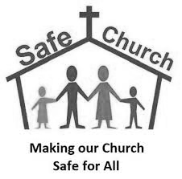
In the Catholic Church, this is demonstrated by the provision of carefully planned activities for children, young people and adults; supporting families under stress; caring for those hurt by abuse in the past; ministering to and managing those who have caused harm. It is because of these varied ministries that in our parish we need to take all reasonable steps to provide a safe environment for all which promotes and supports their wellbeing. This will include carefully selecting and appointing those who work with children, young people or adults at risk and responding robustly where concerns arise.

If you are concerned about the safety of a child or vulnerable adult and feel they are in immediate danger, please call the police. If you wish to report any non-urgent concerns, please contact your local social services or our safeguarding team direct at


or Mark Robson 0151 522 1013 / 07585761965 Claire Newton 0151 522 1043 / 07384643237 or safeguarding@rcaol.org.uk

PARISH WEBSITE & FACEBOOK PAGE To keep up to date with our parish events, news and mass times etc follow the ‘SFX Church Liverpool’ Facebook page or you can find our latest newsletter and lots of useful information on the church website: sfxchurchliverpool.co.uk

SERVICES: 29th June Onwards.

Tuesday | Mass | 12 noon | Josie Foley
Thursday | Mass | 12 noon | Viyann Griffith
Saturday | Mass | 12 noon | Marie Elliot
Sunday | Mass | 10.15am | Parishioners

PLEASE REMEMBER IN YOUR PRAYERS THE FOLLOWING: Josie Foley, Marie Elliot, Louisa Cleary, Billy Rimmer, Anita de Asha, Viyann Griffith.

COLLECTION LAST WEEK £400.52. Thank you for you continuing support of the parish.

Click to donate to the parish.

£5 £10 £20

