St. Francis Xavier’s Church, Liverpool
12th July 2026
www.sfxchurch.co.uk

St Francis Xavier’s Church. Salisbury Street. Liverpool. L3 8DR
Phone: 0151 298 1911 Email: sfxchurch@rcaol.org.uk
Parish Priest: Fr. Chris McCoy
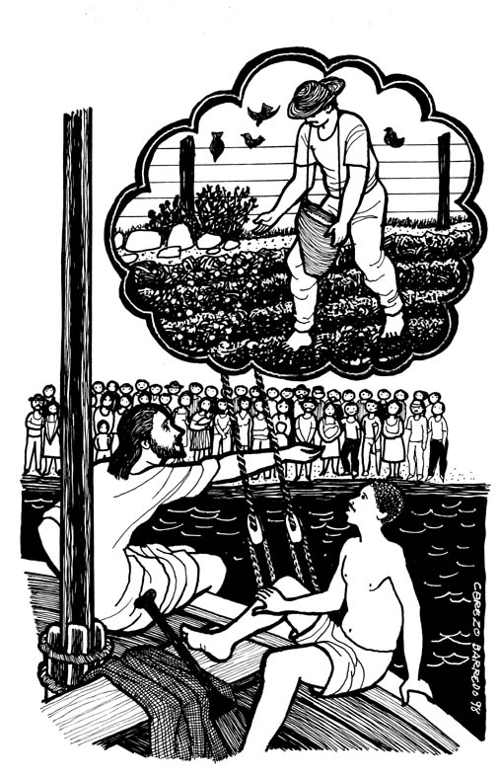
Jesus got into a boat and sat there.
The people all stood on the beach.
He said, ‘Imagine a sower going out to sow.’
Mattthew 13:1-23

15th Sunday of Ordinary time
Mass Readings. Page 259


PARISH BBQ & TOMBOLA TODAY AFTER MASS (12TH JULY) 11am-1pm After the 10.15 mass, in the garden, we are having a parish BBQ (no charge) and tombola. All welcome.
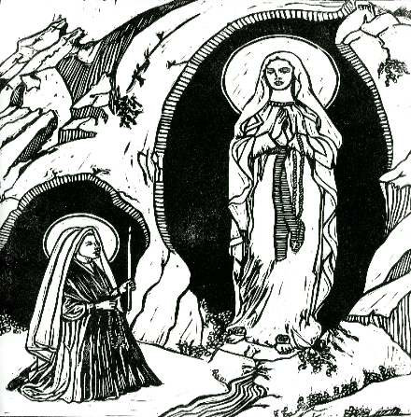
ANNUAL ARCHDIOCESAN LOURDES MASS The annual archdiocesan Lourdes Mass will take place next Sunday 19 July at 3pm at the Metropolitan Cathedral. All are welcome - whether you are travelling on this year’s pilgrimage, have joined us in previous years, or are simply a supporter of the pilgrimage. Archbishop John Sherrington will be the celebrant.

PARISH WEBSITE & FACEBOOK PAGE To keep up to date with our parish events, news and mass times etc follow the ‘SFX Church Liverpool’ Facebook page or you can find our latest newsletter and lots of useful information on the church website: sfxchurchliverpool.co.uk

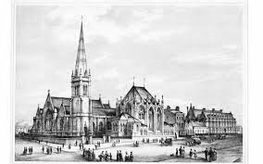

SERVICES: 12th July Onwards.

Tuesday | Mass | 12 noon | Julia Gibbs
Thursday | Mass | 12 noon | Anthony Jennings
Saturday | Mass | 12 noon | Brenda Moorcroft
Sunday | Mass | 10.15am | Parishioners

FORTHCOMING FUNERAL Friday 24th July 11.30am Brenda Moorcroft. May she rest in peace.

HELP KEEP OUR CHURCH TIDY After mass on a Sunday please return hymn books and missals to the end of the bench. Thank you.

PLEASE REMEMBER IN YOUR PRAYERS THE FOLLOWING: Brenda Moorcroft RIP. Josie Foley, Marie Elliot, Louisa Cleary, Billy Rimmer, Anita de Asha RIP, Viyann Griffith.

Click to donate to the parish.

£5 £10 £20

