St. Francis Xavier’s Church, Liverpool
26th July 2026
www.sfxchurch.co.uk
St Francis Xavier’s Church. Salisbury Street. Liverpool. L3 8DR
Phone: 0151 298 1911 Email: sfxchurch@rcaol.org.uk
Parish Priest: Fr. Chris McCoy
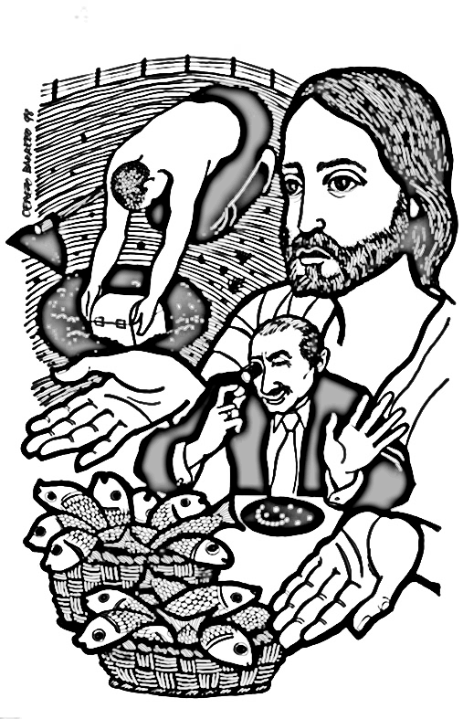
Jesus said ‘The kingdom of heaven is like treasure hidden in a field,
it is like a merchant looking for fine pearls.
it is like a net thrown into the sea,
that brings in a haul of all kinds.’
Mattthew 13:44-52

17th Sunday of Ordinary time
Mass Readings. Page 286


TEA/COFFE & CAKE will be available in the parish meeting room after mass today. All welcome.



PARISH COUNCIL MEETING The next meeting of our SFX Parish Council will be after the summer holidays on Sunday 6th September 11.15am.

PARISH ARCHIVES Here at SFX parish we have papers and documents covering many years of the long history of the parish. At present, they are stored in a small room at the side of the church. They need to be conserved and stored correctly so that they can be consulted when needed. Some of the parish baptism and marriage books from prior to 1936 are already kept in the Liverpool Central Records office where the public can examine them.
The main archive for the whole archdiocese is in the Cathedral crypt. Following discussion and advice from the archdiocesan archivist, Neil Sayer, some of our other material is being moved to archive in the cathedral. They remain the property of the parish, but it means that they will be catalogued and stored correctly in the right climate-controlled conditions.
(The baptism, confirmation, and marriage records from 1936 onwards will stay here at SFX so that we can issue baptism certificates etc, when needed.)


LOURDES SERVICE & PROCESSION AT ST VINCENT DE PAUL PARISH There will be a special Lourdes service and procession at St Vincent’s Church (L1 5JN) on Monday 27th July at 6pm. It will be an opportunity to unite in prayer with the Archdiocesan pilgrimage to Lourdes which is taking place this week. All are welcome

SOCIAL AFTERNOON Our regular Tuesday social group is taking place this week. 1.30pn in the parish meeting room. All welcome.


PARISH WEBSITE & FACEBOOK PAGE Stay up to date with parish events, news and Mass times by following the ‘SFX Church Liverpool’ Facebook page. You can also find the latest newsletter and other useful information on our church website: sfxchurchliverpool.co.uk

SERVICES: 26th^{th} July Onwards.

Tuesday | Mass | 12 noon | Mary Jennings
Wednesday | Funeral | 2.30pm | Teresa Smart RIP
Thursday | Mass | 12 noon | Margaret Shaw
Saturday | Mass | 12 noon | Ann Shakleton
Sunday | Mass | 10.15am | Parishioners

PLEASE REMEMBER IN YOUR PRAYERS THE FOLLOWING: Julia Gibbs, Anthony Jennings, Ann Shakleton, Mary Jennings, Brenda Moorcroft RIP. Josie Foley, Marie Elliot, Louisa Cleary, Billy Rimmer, Teresa Smart RIP, Anita de Asha RIP, Viyann Griffith.

COLLECTION LAST WEEK £304.75. Thank you.

Click to donate to SFX parish.

£5 £10 £20

