St. Francis Xavier’s Church, Liverpool
16th August 2026
www.sfxchurch.co.uk
St Francis Xavier’s Church. Salisbury Street. Liverpool. L3 8DR
Phone: 0151 298 1911 Email: sfxchurch@rcaol.org.uk
Parish Priest: Fr. Chris McCoy
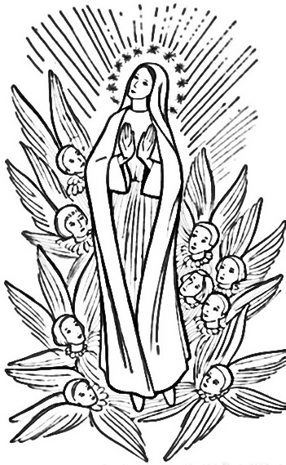
Today’s Gospel reading Luke 1:39-56
‘My soul proclaims the greatness of the Lord’
The Assumption of Mary.
Mass Readings. Page 723

PARISH COUNCIL MEETING The next meeting of our SFX Parish Council will be after the summer holidays on Sunday 6th September 11.15am.

PARISH BBQ A date for your diary: we are planning to have another parish BBQ on Sunday 27th September after mass. Save the date!

PARISH WEBSITE & FACEBOOK PAGE Stay up to date with parish events, news and Mass times by following the ‘SFX Church Liverpool’ Facebook page. You can also find the latest newsletter and other useful information on our church website: sfxchurchliverpool.co.uk

EVENING PRAYER WITH THE APOSTOLIC NUNCIO Sunday 13 September at 3pm. All are invited to assemble as our archdiocesan family at the Metropolitan Cathedral of Christ the King on Sunday 13 September at 3pm for the culmination of the Apostolic Nuncio’s visit to the archdiocese. This date coincides with the 175th anniversary of the establishment of the Metropolitan Chapter of Liverpool.
The celebration with take the form of Evening Prayer sung in the Cathedral. There will be a drinks reception following in the Cathedral crypt.
The Apostolic Nuncio will also celebrate the Solemn Mass at 11am in the Cathedral on that date.

ONE MONTH until MPs debate assisted suicide bill.
The Terminally Ill Adults (End of Life) Bill returns to the House of Commons for its Second Reading on 11 September. Those wishing to express their opposition are encouraged to contact their MP using the online resources provided by CBCEW in association with Right to Life UK. For more information and resources, visit: cbcew.org.uk/opposing-assisted-suicide or righttolife.org.uk/Sept11vote


50 YEARS OF LOURDES MEMORIES are captured in one beautiful scrapbook. From iconic photos to quirky facts and the stories that shaped our pilgrimage family, this anniversary edition is something truly special.
📘 £10
📘 £15 with commemorative badge
Every penny supports our Youth Pilgrimage, helping the next generation make their own memories.
To purchase, contact: admin@animateyouth.co.uk or 01744 740461

SERVICES: 16th August Onwards.

Tuesday | Mass | 12 noon | Kathleen Dalton
Thursday | Mass | 12 noon | Marie Elliot
Sunday | Mass | 10.15am | Parishioners

PLEASE REMEMBER IN YOUR PRAYERS THE FOLLOWING: John Drew. Christopher Long RIP, J & C Hardacre, M Jones, Mickey Bennett, Olive Fitzpatrick, Dorothy: Rogan, Williams & Kinsella families.

COLLECTION LAST WEEK £332.10. Thank you for your continued support of the parish.

Click to donate to SFX parish.

£5 £10 £20

