St. Francis Xavier’s Church, Liverpool
27th September 2026
www.sfxchurch.co.uk
St Francis Xavier’s Church. Salisbury Street. Liverpool. L3 8DR
Phone: 0151 298 1911 Email: sfxchurch@rcaol.org.uk
Parish Priest: Fr. Chris McCoy
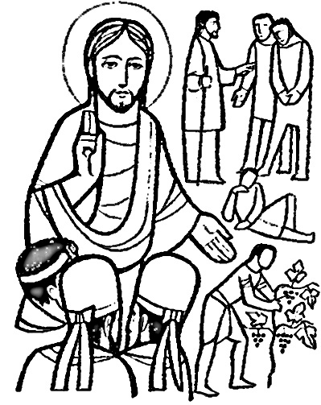
Jesus said to the chief priests: ‘A man had two sons,
Which of them did the fathers will?’
Matthew 21:28-32

26th Sunday year A
Mass Readings. Page 369

BAPTISM TODAY DURING THE MASS It is a real joy to welcome Daniel Pendleton to mass today: he will be baptised and welcomed into the family of the church. Past the past six months he has been preparing this important step in his life. As well as being baptised as an adult, Fr Chris will confirm him and Danny will also make his first communion.

PARISH BBQ Today, Sunday (27th September) after mass. All are welcome.

As well as the BBQ there will be some food prepared by some of the younger international members of the congregation


PARKING ON THE STREETS NEAR THE CHURCH Last week several people were given parking tickets on Sunday morning during mass time. Unfortunately, parking restrictions are being tightened up in the area. Be careful where you park! Traffic wardens do apply the rules even on a Sunday morning

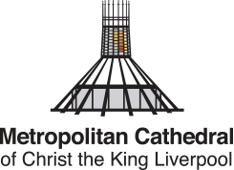
ADOREMUS – Saturday 10 October 9am – 6pm at Liverpool Metropolitan Cathedral. Join us on the 10th of October for this year’s Adoremus. The theme this year is “How we are Eucharist”. Come and join us to adore the Lord Jesus in the Blessed Sacrament. The event itself is free and available to all. At the Metropolitan Cathedral, there will be Eucharistic Adoration throughout the day, Mass, opportunities for confession, a variety of workshops and a shared time of prayer during the day for all. Sign up for workshops here: archdioceseofliverpool.org/adoremus2026 ‘

EUCHARISTIC MININSTER TRAINING Saturday 28 November – The Irenaeus Centre (L22 1RD) The course examines our baptismal calling, Vatican II’s teaching on ministry, and the role of the Eucharistic minister. The day runs from 9.15 am to 4pm Parishes are asked to contribute £15 per attendee to cover costs. Places must be booked and paid for in advance.

UPDATED Young Adults Mass with Archbishop John Sherrington – Thursday 3 October. Archbishop John Sherrington invites young people aged 18-35 to celebrate Mass with him on Saturday 3 October, 5pm at St Philip Neri Church, Liverpool L8 7NL. The meal following the Mass is now fully booked, but all are still very welcome to the Mass.
For enquiries, please contact Moses at

SERVICES: 27th September Onwards.

Tuesday | Mass | 12 noon | David Bigly
Sunday | Mass | 10.15am | Parishioners

COLLECTION Last week: 316.31 Thank you for supporting the parish.


MAKING A DONATION TO THE PARISH BY CARD Lots of people don’t carry money these days and prefer to pay things by card or on their phone. For the next couple of weeks, we are trying out a new system, developed by a couple of technically minded parishioners, for donating to the parish. At the back of church there is a small screen which you can tap with your card or phone to donate. Thank you.

PLEASE REMEMBER IN YOUR PRAYERS THE FOLLOWING: Paul Dickenson, Mrs Higden, David Bigly, J&T Morgan, Jackie Griffiths, John Drew. Chrissie Pearson, Christopher Long RIP, J & C Hardacre, M Jones

Click to donate to SFX parish.

£5 £10 £20

