St. Francis Xavier’s Church, Liverpool
4th October 2026
www.sfxchurch.co.uk
St Francis Xavier’s Church. Salisbury Street. Liverpool. L3 8DR
Phone: 0151 298 1911 Email: sfxchurch@rcaol.org.uk
Facebook: SFXchurch
Parish Priest: Fr. Chris McCoy
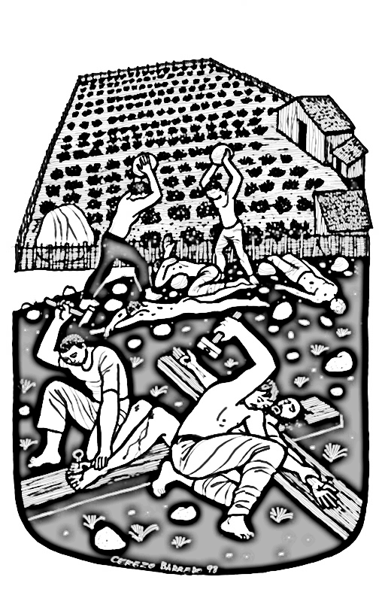
Jesus said to the chief priests: ‘There was a man,
a landowner, who planted a vineyard..’
Matthew 21:33-43

27th Sunday year A
Mass Readings. Page 377

WELCOME. Today, Sunday, we welcome Mgr. Steven Alker who will be leading our celebration of mass. Thank you, Fr Steven, for being with us.

THANK YOU. The parish BBQ last Sunday after mass was a lovely occasion. Even the sun came out! Thank you to all who came and special thanks to all who prepared it and helped. It was good to see so many young and old mixing together. Several other social events, film and quiz nights, are planned for later in October and November, dates to be confirmed soon.

TUESDAY SOCIAL GROUP The group is meeting this week at 1.30pm in the parish meeting room. All welcome.

PARKING ON THE STREETS NEAR THE CHURCH Recently people were given parking tickets on Sunday morning during mass time. Parking restrictions are being tightened up in the area. Be careful where you park! Traffic wardens are about and they do apply the rules even on a Sunday morning.

ADOREMUS – Next Saturday 10 October 9am – 6pm at Liverpool Metropolitan Cathedral. The theme this year is “How we are Eucharist”. Come along for as long as you want and spend some time in adoration of the Lord Jesus in the Blessed Sacrament. The event itself is free and available to all. Call in at any time. At the Metropolitan Cathedral, there will be Eucharistic Adoration throughout the day, Mass, opportunities for confession, a variety of workshops and a shared time of prayer during the day for all. Sign up for workshops here: archdioceseofliverpool.org/adoremus2026 ‘

NEW STUDENTS: UNIVERSITY CHAPLAINCY The Chaplaincy to the University of Liverpool, John Moores University and the Liverpool Institute of Performing Arts is based at St Philip Neri Church on Catharine St, L8 7NL. They offer a place of welcome and hospitality for students and staff. There is a student Sunday Mass at 6pm during term time, and many events through the week and the academic year, helping students to explore their faith, develop their prayer life, and – importantly! socialise with each other and have fun. The chaplain is Fr Neil Ritchie, and he is always available to help and support students and staff, whether they are Catholic, are interested in the church or just like what we have on offer. There is a very active student led Catholic Society. There is a group for staff members which meets fortnightly at the chaplaincy; in the coming year we will be reading together and discussing ‘The Afternoon of Christianity’ by Tomáš Halík. If you are interested, please contact Fr Neil. The chaplaincy website is www.cathchap.org.uk Fr Neil’s email: n.ritchie@rcaol.org.uk
Phone: 0151 709 3858

EUCHARISTIC MINISTER TRAINING Saturday 28 November – The Irenaeus Centre (L22 1RD) The course examines our baptismal calling, Vatican II’s teaching on ministry, and the role of the Eucharistic minister. The day runs from 9.15 am to 4pm Parishes are asked to contribute £15 per attendee to cover costs. Places must be booked and paid for in advance

SERVICES: 4th October Onwards.
Saturday | Mass | 12 noon | M&P Rebbeca
Sunday | Mass | 10.15am | Parishioners

COLLECTION Last week: 370.18. (This figure does not include the contactless donations from last week.) Thank you for supporting the parish.
MAKING A CONTACTLESS DONATION TO THE PARISH BY CARD Lots of people don’t carry money these days and prefer to pay things by card or on their phone. For the next couple of weeks, we are trying out a new system, developed by a couple of technically minded parishioners, for donating to the parish. At the back of church there is a small screen which you can tap with your card or phone to donate. Thank you.

PLEASE REMEMBER IN YOUR PRAYERS THE FOLLOWING: Paul Dickenson, Mrs Higden, David Bigly, J&T Morgan, Jackie Griffiths, John Drew. Chrissie Pearson, Christopher Long RIP, J & C Hardacre, M Jones

Click to donate to SFX parish.

£5 £10 £20

